

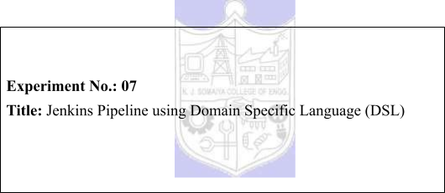



|  |  |  |
| --- | --- | --- |
| **Batch:B1** | **Roll No.:16010421119** | **Experiment No.:** 07 |

**Aim:** To create and run Jenkins pipeline using Domain Specific Language (DSL)



**Resources needed: Jenkins**



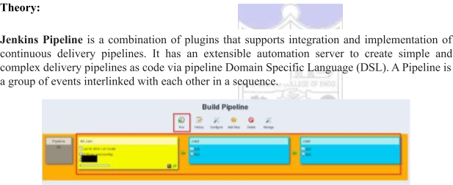

Jenkins job DSL is a plugin that allows us to define jobs in programmatic form with minimal effort. You can describe your jobs in Jenkins using a Groovy Based Language. It is similar to java but simpler because it’s much more dynamic. It is Scripting Language. Jenkins job DSL plugin was designed to make it easier to manage jobs.



**Procedure:**

1. Install build pipeline and view pipeline   
2. Create sample jobs [example: build, test and Deploy].   
3. Create a pipeline for the same using script or jenkinsfile.

4. Check the view pipeline to see the execution process.

**Results: (Document with screenshots)**

1. All steps to install, configure pipeline

2. View pipeline execution process



python app which we are gonna run through CI





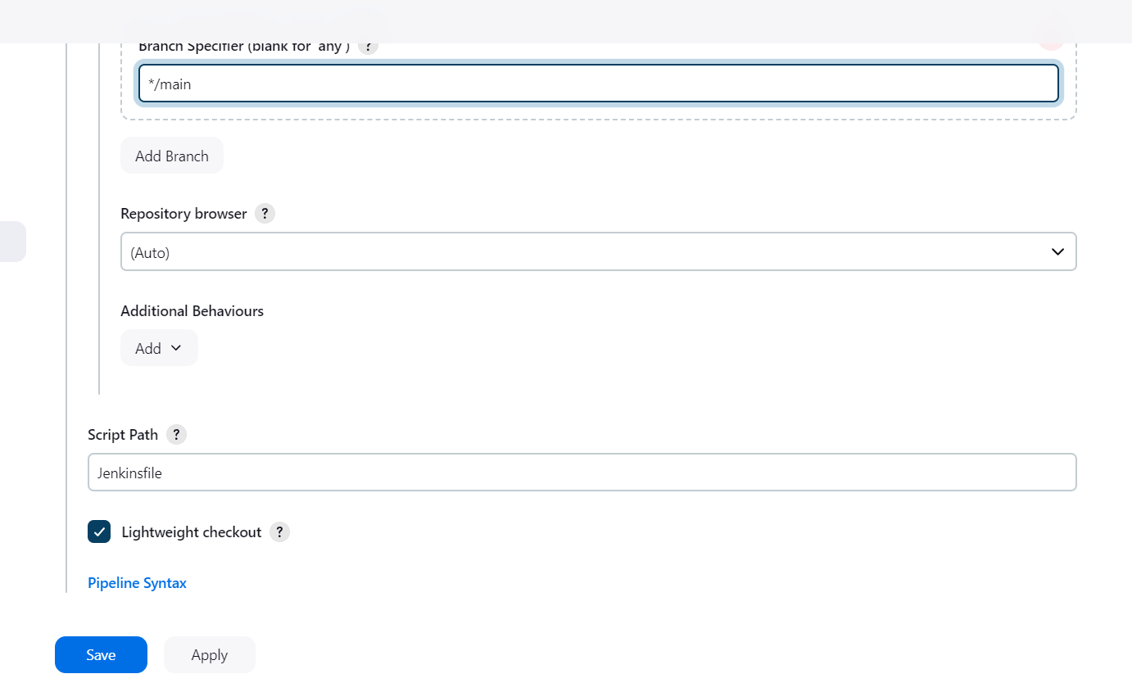

Add the script path to Jenkinsfile

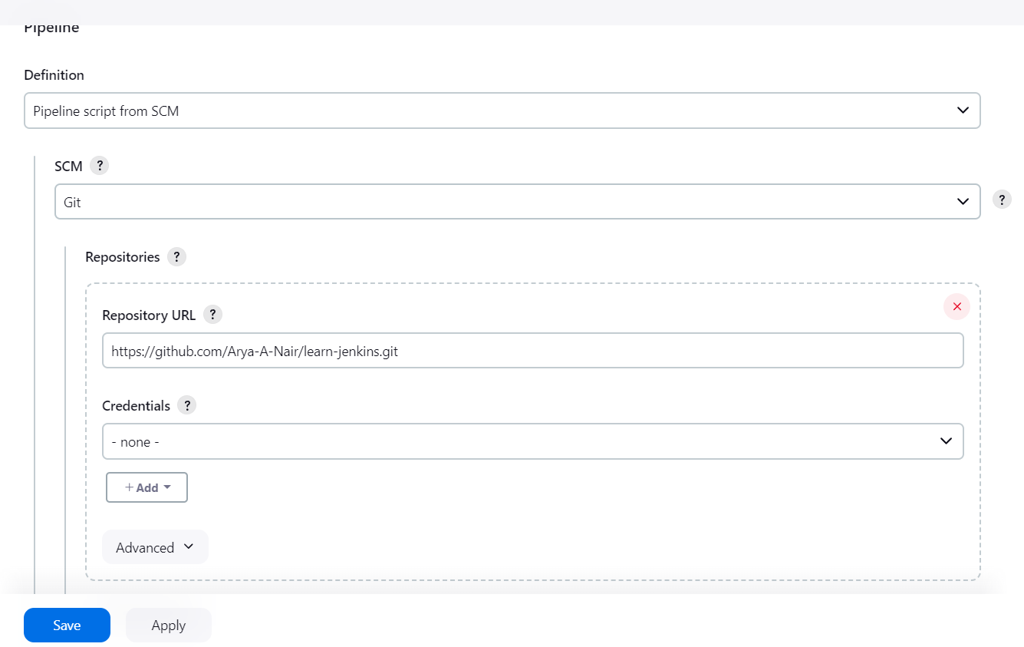

Add the repository url to clone the code base



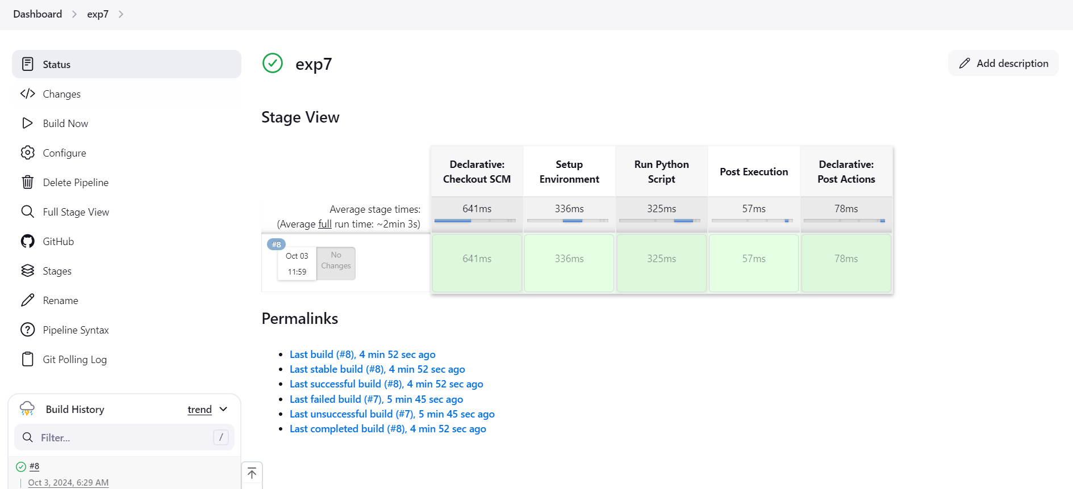

Pipeline created using the jenkins file

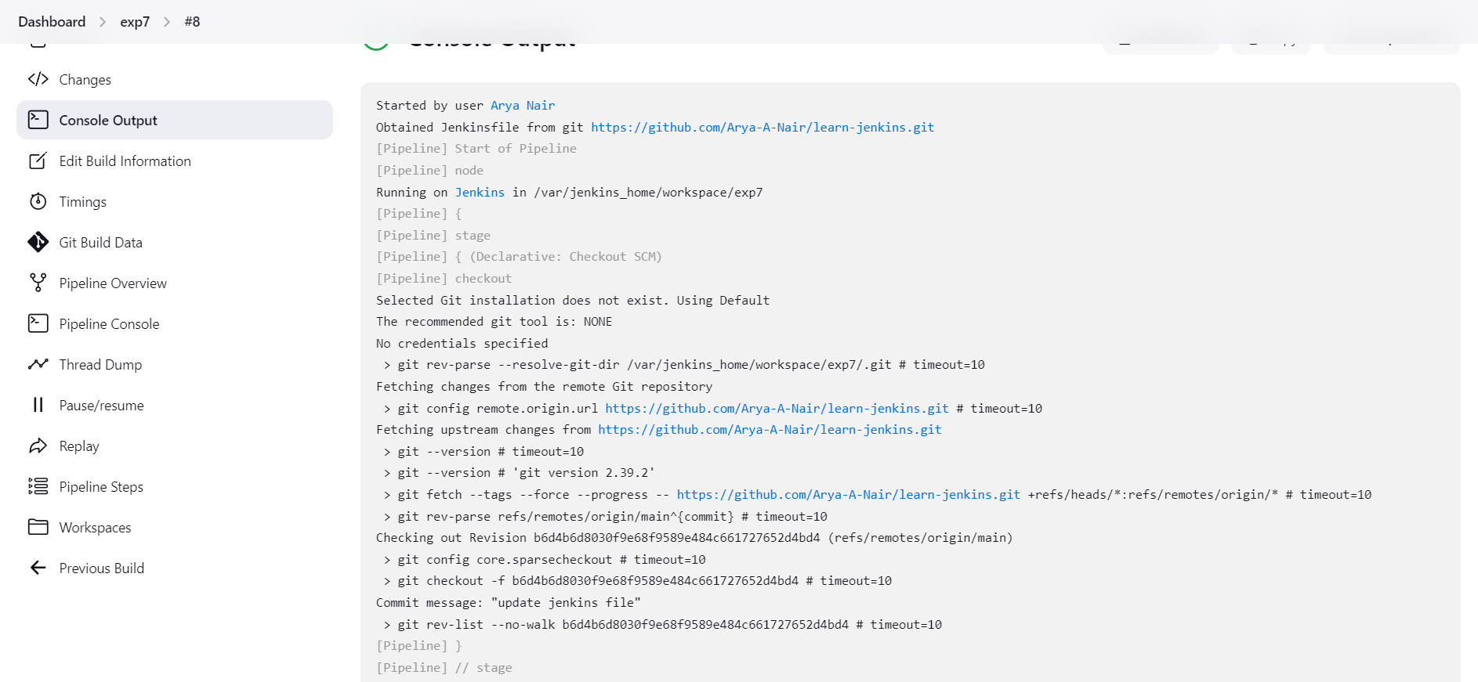

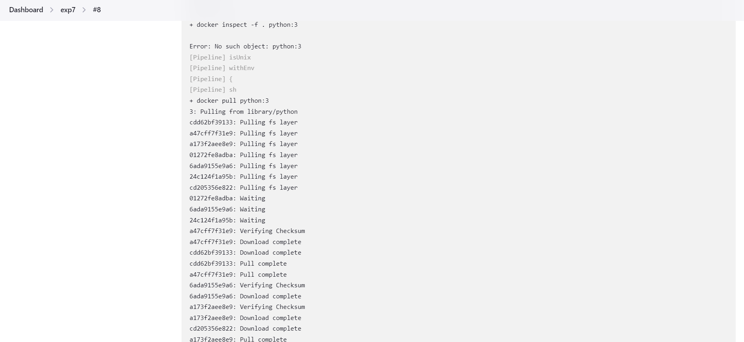



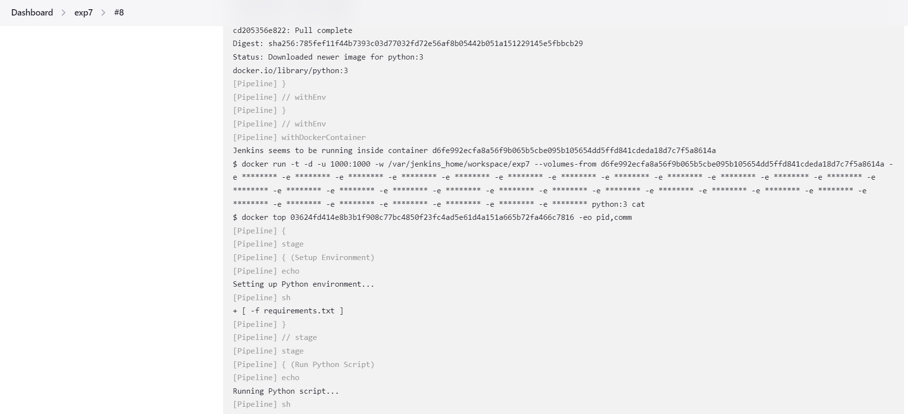

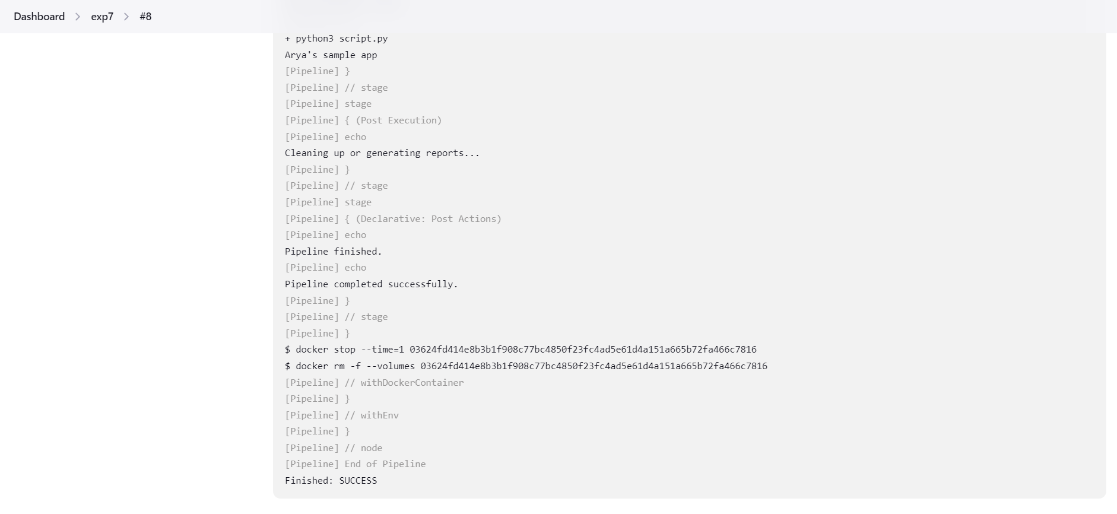

Output of code being run



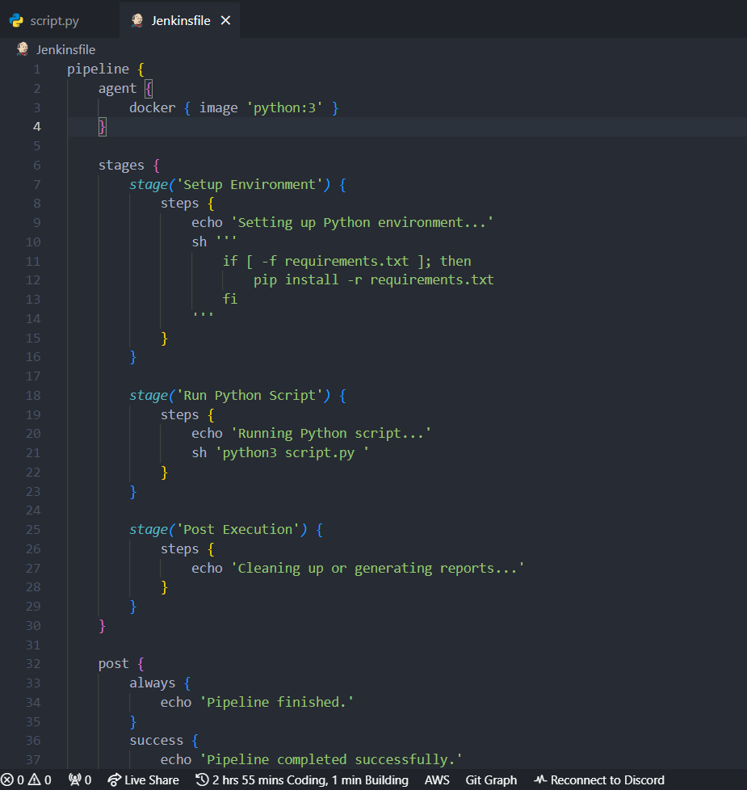

Jenkinsfile which creates the pipeline

**Questions:**

1. Explore “DevOpsDream game on [https://devops.games](https://devops.games/)”. DevOpsDream built as a tool for learning about what works and doesn’t work in the world of software development. The DevOpsDream is an attempt to inspire you to think about how you develop and run software. Read the instructions and play the game.

Prepare summary sheet for the same. (Understanding of concept, Snapshot of best result)



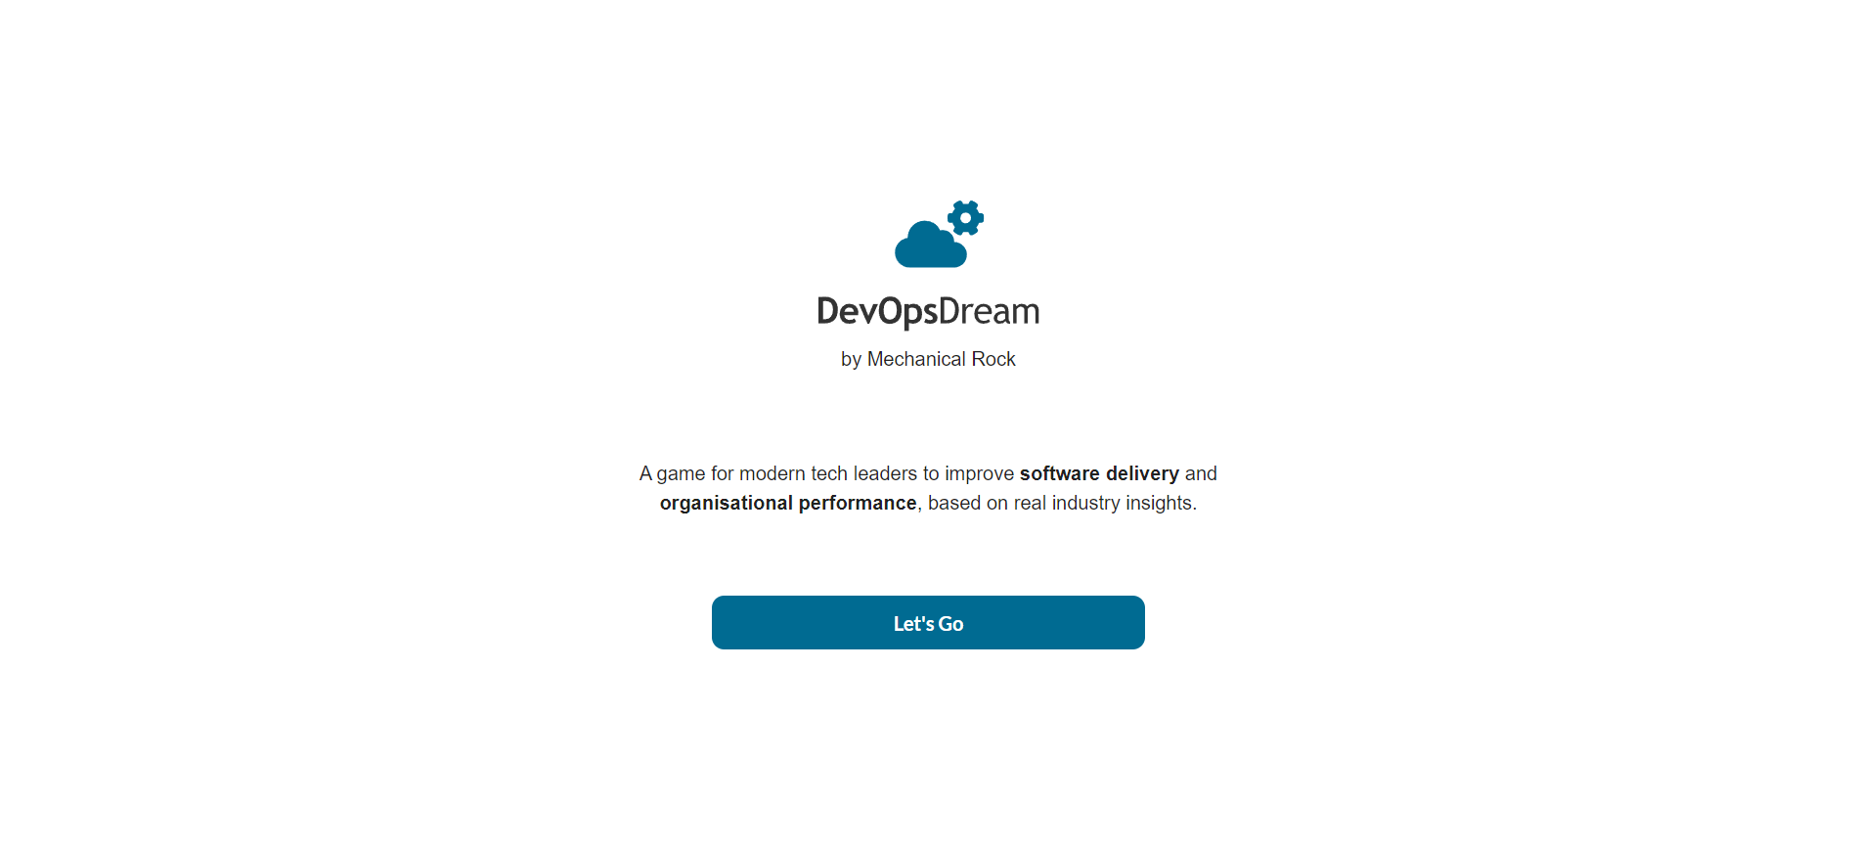

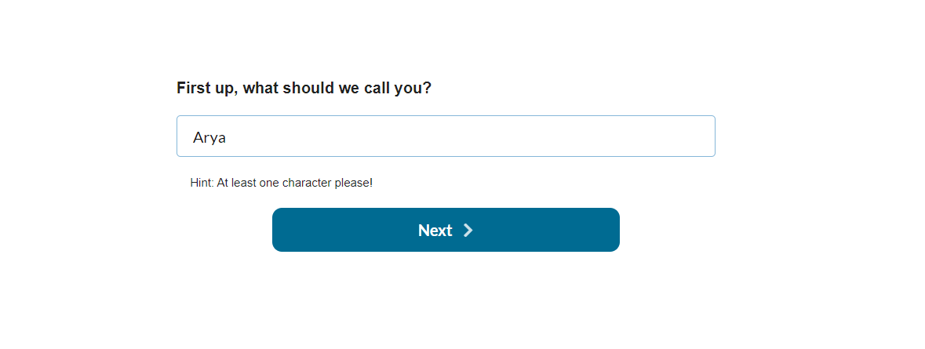



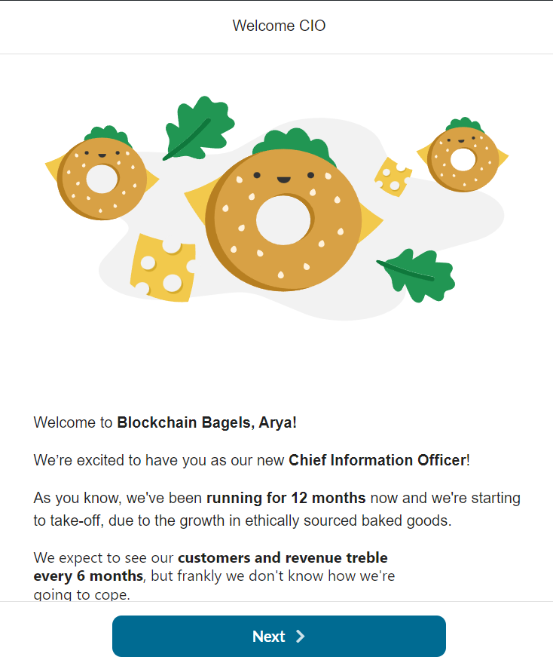



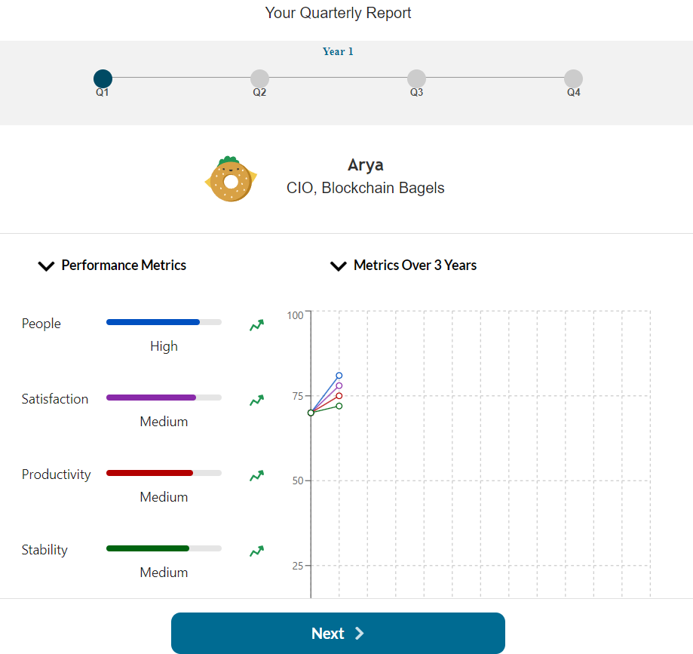



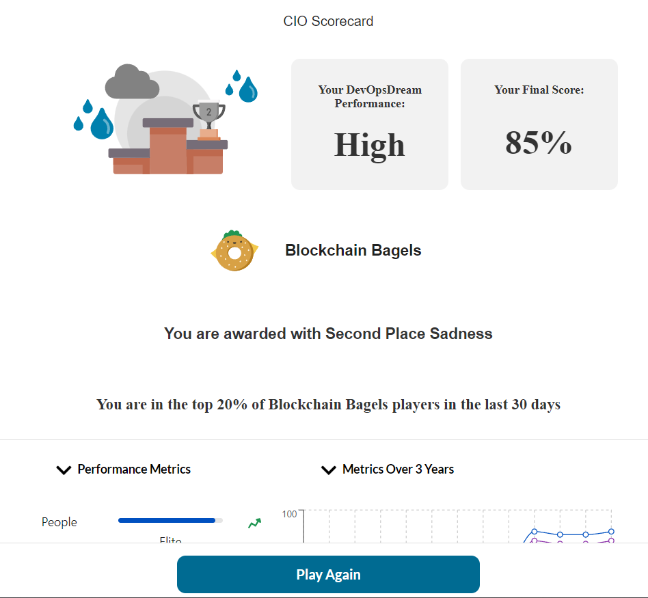



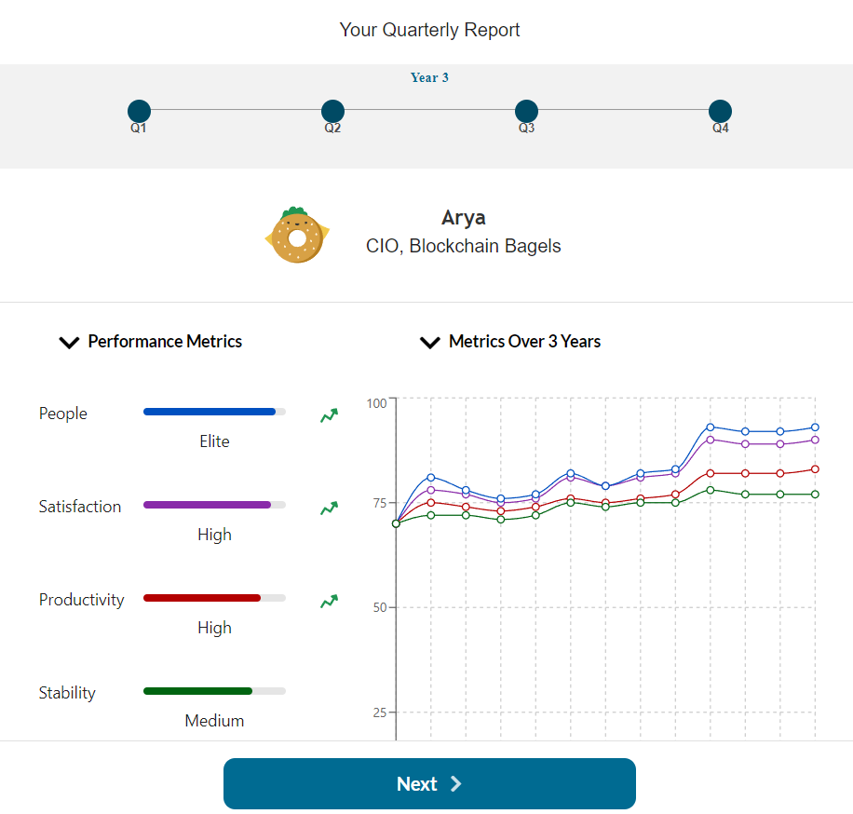

2. How game based learning helps in understanding concept, logic and decision making? these situations make me think about how developer operations would work in an actual organisation settings. along with managing the technological approach while maintaining the reliability in releasing to the client



**Outcomes:CO4 Explain code deployment and monitoring systems and their tool support.**





**Conclusion: (Conclusion to be based on the Results and outcomes achieved)** Wrote jenkinsfile and run the various stages





**Grade: AA / AB / BB / BC / CC / CD /DD**

**Signature of faculty in-charge with date**



**References:**   
**Books/ Journals/ Websites:**

1. Jenkins Pipeline Tutorial: https:/[/www.guru99.c](http://www.guru99.com/jenkins-pipeline-tutorial.html)o[m/jenkins-pipeline-tutorial.html](http://www.guru99.com/jenkins-pipeline-tutorial.html) 2. Part1-SDET Essentials | Jenkins Build & Delivery Pipeline | CI & CD | How to create Jenkins Pipeline: <https://www.youtube.com/watch?v=1ji_9scA2C4>  
3. Part2-SDET Essentials|CI & CD|How to Build Pipelines with Groovy Script|Scripted & Declarative: <https://www.youtube.com/watch?v=Ozna0MS5D1E>  
4. Jenkins Pipeline Tutorial | CI/CD Pipeline Jenkins | Jenkins Tutorial | DevOps Training Edureka: <https://www.youtube.com/watch?v=_fmX31VFbL8&t=1796s>

|  |  |  |  |  |  |  |  |  |  |
| --- | --- | --- | --- | --- | --- | --- | --- | --- | --- |
| 5. DevOps | CI/CD | Jenkins | Pipeline, | Ansible | & | Docker | | | For | DevOps |

https:/[/www.youtube.com/watch?v=13FpCxCClLY](http://www.youtube.com/watch?v=13FpCxCClLY)   
6. Effective DevOps: Building a Culture of Collaboration, Affinity, and Tooling at Scale, Jennifer Davis, Ryn Daniels, O'Reilly Media June 2016.

7. Practical DevOps: Implement DevOps in your organization by effectively building, deploying, testing, and monitoring code,Joakim Verona, Packt Publishing, 2nd Edition,2016   
8. https://devops.games